A000-MEX-Aztec-Tarascan culture-Celts-Guerrero Michoacan-Post Classic-1200 CE

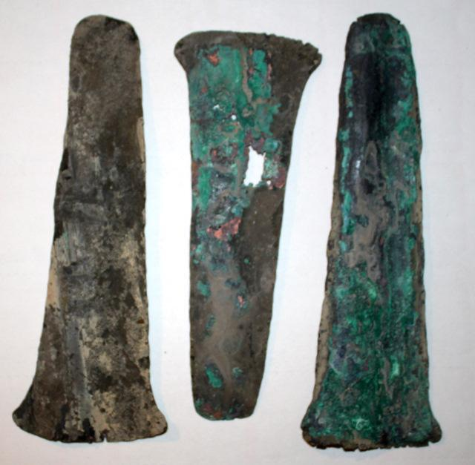

Figs. 1-3. Aztec-Tarascan culture-Celts-Guerrero Michoacan-Post Classic-1200 CE

Case No.: 10

**Accession No.**

**Formal Label:** Aztec-Tarascan culture-Celts-Guerrero Michoacan-Post Classic-1200 CE

**Display Description:**

Three thin copper alloy Tajaderas from the post Classic period. Likely from the Tarascan culture of the Guerrero - Michoacan area of Mexico. Sometimes referred to as "Aztec Money", these are thought to have been used as currency during that period. Nice intact examples with considerable green oxidation. c 1200 CE

**LC Classification:** F1219.3.R38

**Date or Time Horizon:**

**Geographical Area:** Guerrero Michoacan

**Map:**

**GPS coordinates:**

**Cultural Affiliation:** Aztec-Tarascan culture-

**Media:** copper allo**y**

**Dimensions:** 5.5" to 6.25"

**Weight:**

**Condition:** Great patina and in fine, near excellent condition.

**Provenance:**

**Discussion:**

**References:**